KOLOLO SECONDARY SCHOOL

DEPARTMENT OF GEOGRAPHY

SENIOR ONE ASSESSMENT

TERM ONE 2023

1. Geography is the study of the relationship between people and the environment, both natural and human made.

Explain **three** ways people in the area where you stay use the natural environment to earn a living

..............................................................................................................................................................................................................................................................................................................................................................................................................................................................................................................................................................................................................................................................................................................................................................................................................................................................................................................................................................................................................................................................................................................................................................................................................................................................................

**(06 Scores)**

1. The study of Geography helps you to understand how your life and that of other people is affected by the environment.

Imagine your friend who has been in a rural area is shifting to stay in Kampala city. Explain **two** activities they will do to survive in a city environment

........................................................................................................................................................................................................................................................................................................................................................................................................................................................................................................................................................................................................................................................................................................................................................................................................................................................................................................................................................................................................................

**(04 Scores)**

1. The state of the environment in Uganda has reached worrying levels. It has become normal for people to carry out activities without regard their impact on the environment.
2. Describe **four** activities people living in your community do that destroy the environment

............................................................................................................................................................................................................................................................................................................................................................................................................................................................................................................................................................................................................................................................................................................................................................................................................................................................................................................................................................................................................................................................................................................................................................................................................................

**(08 Scores)**

1. Caring for and preserving the environment should be a collective responsibility.

You have been appointed the environment prefect for your school. Describe the activities you will recommend your school to do in order to preserve the environment

...............................................................................................................................................................................................................................................................................................................................................................................................................................................................................................................................................................................................................................................................................................................................................................................................................................................................................................................................................................................................................................................................................................................................................................................................................................................................................................................................................................................................................................................................................................................................................................................................................................................................

**(08 scores)**

1. An Atlas is a book that contains maps. People who draw or make maps are called cartographers. Fountain Publishers, a leading publishing houses in Uganda is in the process of making an atlas.

If you are appointed a cartographer by Fountain publishers, describe the qualities you will consider when drawing maps

.........................................................................................................................................................................................................................................................................................................................................................................................................................................................................................................................................................................................................................................................................................................................................................................................................................................................................................................................................................................................................................................................................................................................................................................................................................................................................................................................................................................................................................................................................................................................................................................................................................................................................................................................................................................................

**(08 Scores)**

1. When planning and designing a map of an area, one of the main qualities to consider is a scale.

Explain **two** reasons why it is important to use a scale when drawing a map

...............................................................................................................................................................................................................................................................................................................................................................................................................................................................................................................................................................................................................................................................................................................................................................................................................................................................................................................................................................................................................................................................................................................................................................................................................................................................................................................................................................................................................................................................................................................................................................................................................................................................

**(04 scores)**

1. Maps contain very useful information. Such information can guide the user of the map about the way of life of the people living in the area.

Observe the map of Lugazi area provided below and do the task that follows:

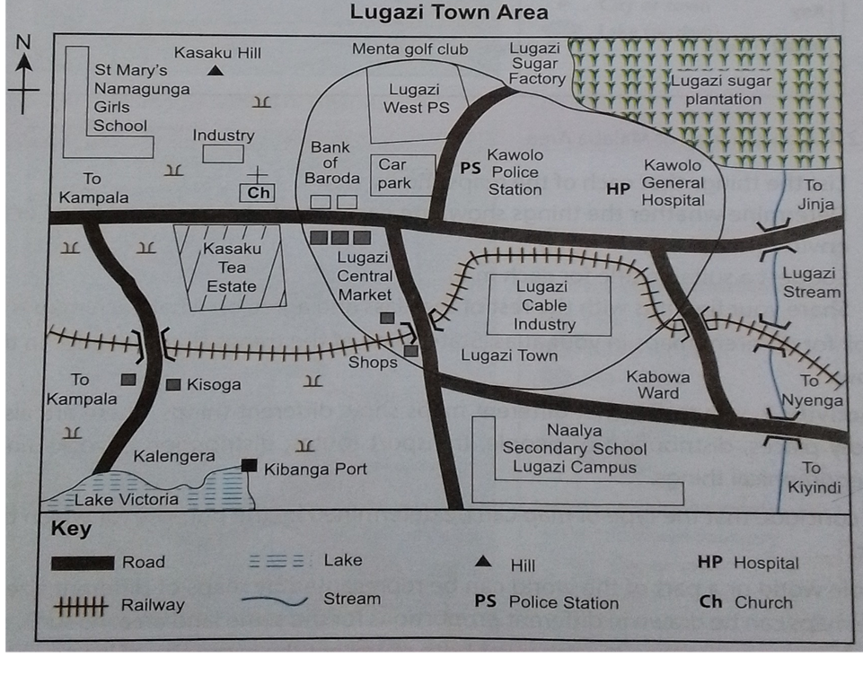

Explain the activities carried out by the people living in Lugazi town area

..............................................................................................................................................................................................................................................................................................................................................................................................................................................................................................................................................................................................................................................................................................................................................................................................................................................................................................................................................................................................................................................................................................................................................................................................................................................................................

(04 scores)